Project Development Phase
Model Performance Test

Date | 03 October 2026
Team ID | SWTID-2026-4339
Project Name | Streamlining IT Procurement: Automating Standard Laptop Orders with Flow Designer
Maximum Marks

Model Performance Testing:
Project team shall fill the following information in model performance testing template.
S.No. | Parameter | Screenshot / Values
 | Data Rendered | Procurement request data exported from ServiceNow (request number, requester, department, laptop model, approval status, opened and closed dates) and loaded into Power BI as an Excel/CSV source.
 | Data Preprocessing | Power Query: removed duplicate request records, handled null approval and closure dates, set date fields to Date type, and standardized laptop model names.
3. | Utilization of Data Filters | Slicers used: Department, Laptop Model, Approval Status and Request Date range, synced across all report pages.
4. | DAX Queries Used | Fulfilment Days = DATEDIFF(Requests[Opened], Requests[Closed], DAY)  Approval Rate = DIVIDE(CALCULATE(COUNTROWS(Requests), Requests[Status]="Approved"), COUNTROWS(Requests))  Avg Fulfilment Time = AVERAGE(Requests[Fulfilment Days])
5. | Dashboard design | No of Visualizations / Graphs - 4 (requests by status, orders by laptop model, average fulfilment time trend, requests by department)  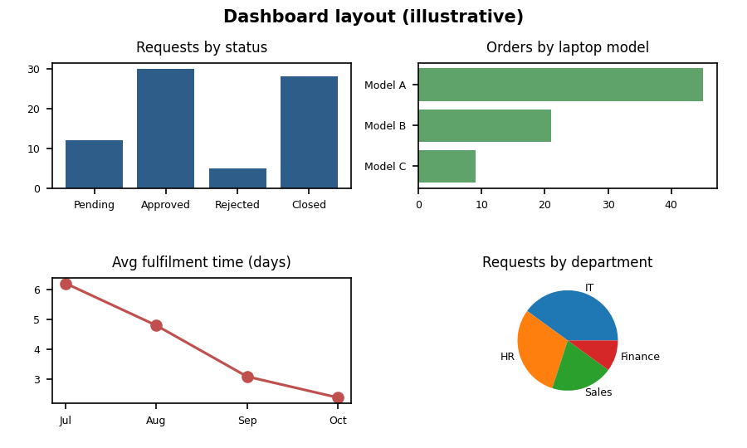
6 | Report Design | No of Visualizations / Graphs - 6 across 2 report pages (4 dashboard visuals plus a detailed requests table and 3 KPI cards)

